Derrick Murphy

Project 1: CS Research, Sub-system: Design

**Definition:**

Description:

Sub-system for the design of Multiscale methods for accurate, efficient, and Scale-aware models of the earth system project. Demonstrates the design process for the teams focus project.

Problem Statement:

Produce better climate models across the full range of spatial and temporal resolutions required to address the needs of both the climate sciences and policy-oriented communities

Assumptions:

 This project is to improve the climate system by addressing the time stepping methods used to integrate the model across the multiple ranges of space and time scales in the atmosphere and utilize hybrid architectures such as GPU to maximize simulation efficiency

Constraints:

Storm Interruptions, Extreme climate changes, User Operability.

Feasibility Analysis:

*Technical*

-Partner with members of QUEST for validation, verification, and uncertainty quantification of our prototypes for multiscale earth system components.

Work with FASTMath investigators to exploit advanced methods for variable-resolution grid generation and for implicit time integration required for accurate yet economical time evolution of our new multiscale model physics.

Collaborate with members of SUPER to optimize the computational performance of core algorithms of variable resolution dycores using auto-tuning techniques

*Economic*

The budget for the overall company (ORNL) is 1.5 billion. For the division of CS Research the budget is 375 million

*Operational*

-Based on finite element and finite volume formulations already developed by team members. Effective deployment of these dynamical cores requires significant and concurrent advances in time-stepping methods, grid generation, and automated optimization methods for next-generation computer architectures

Evaluation Criteria:

Our work is also directly relevant to the goal of DOE's Office of Biological and Environmental Research (BER) to produce “improved scientific data and models about the potential response of the Earth's climate and terrestrial biosphere to increased greenhouse gas levels for policy makers to determine safe levels of greenhouse gases in the atmosphere." This project will deliver a new generation of climate models capable of producing climate projections from local to global scales, in support of energy and other sectoral planning requirements

**Requirements Analysis:**

Requirements Matrix:

|  |  |  |  |  |  |
| --- | --- | --- | --- | --- | --- |
| Function/ Component | Input | Processing | Output | Storage | Control/Security |
| Software |  | CAM –  Modeling Software |  |  | Validation  Verification |
| Hardware/ Network |  | GPU |  | Implementation |  |
| Data | **Parameterizations:**  Wind speed  Longitude, latitude  Water temp  Ocean Depth | **Parameterizations:**  Wind speed  Longitude, latitude  Water temp  Ocean Depth |  |  |  |
| Information |  |  | Simulation Design |  |  |
| People | Scientist  Engineers |  |  |  | Scientist  Engineers |

Gantt Chart:

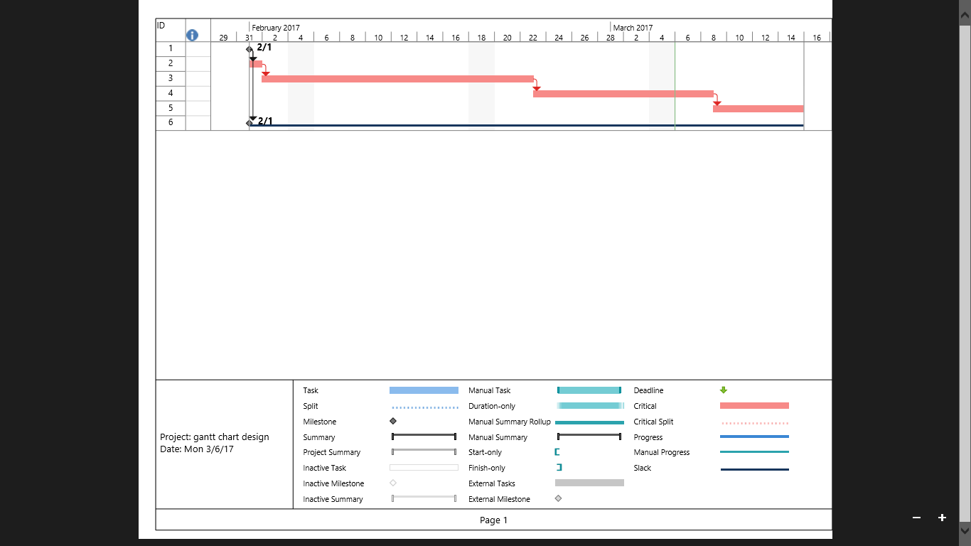

**Design**

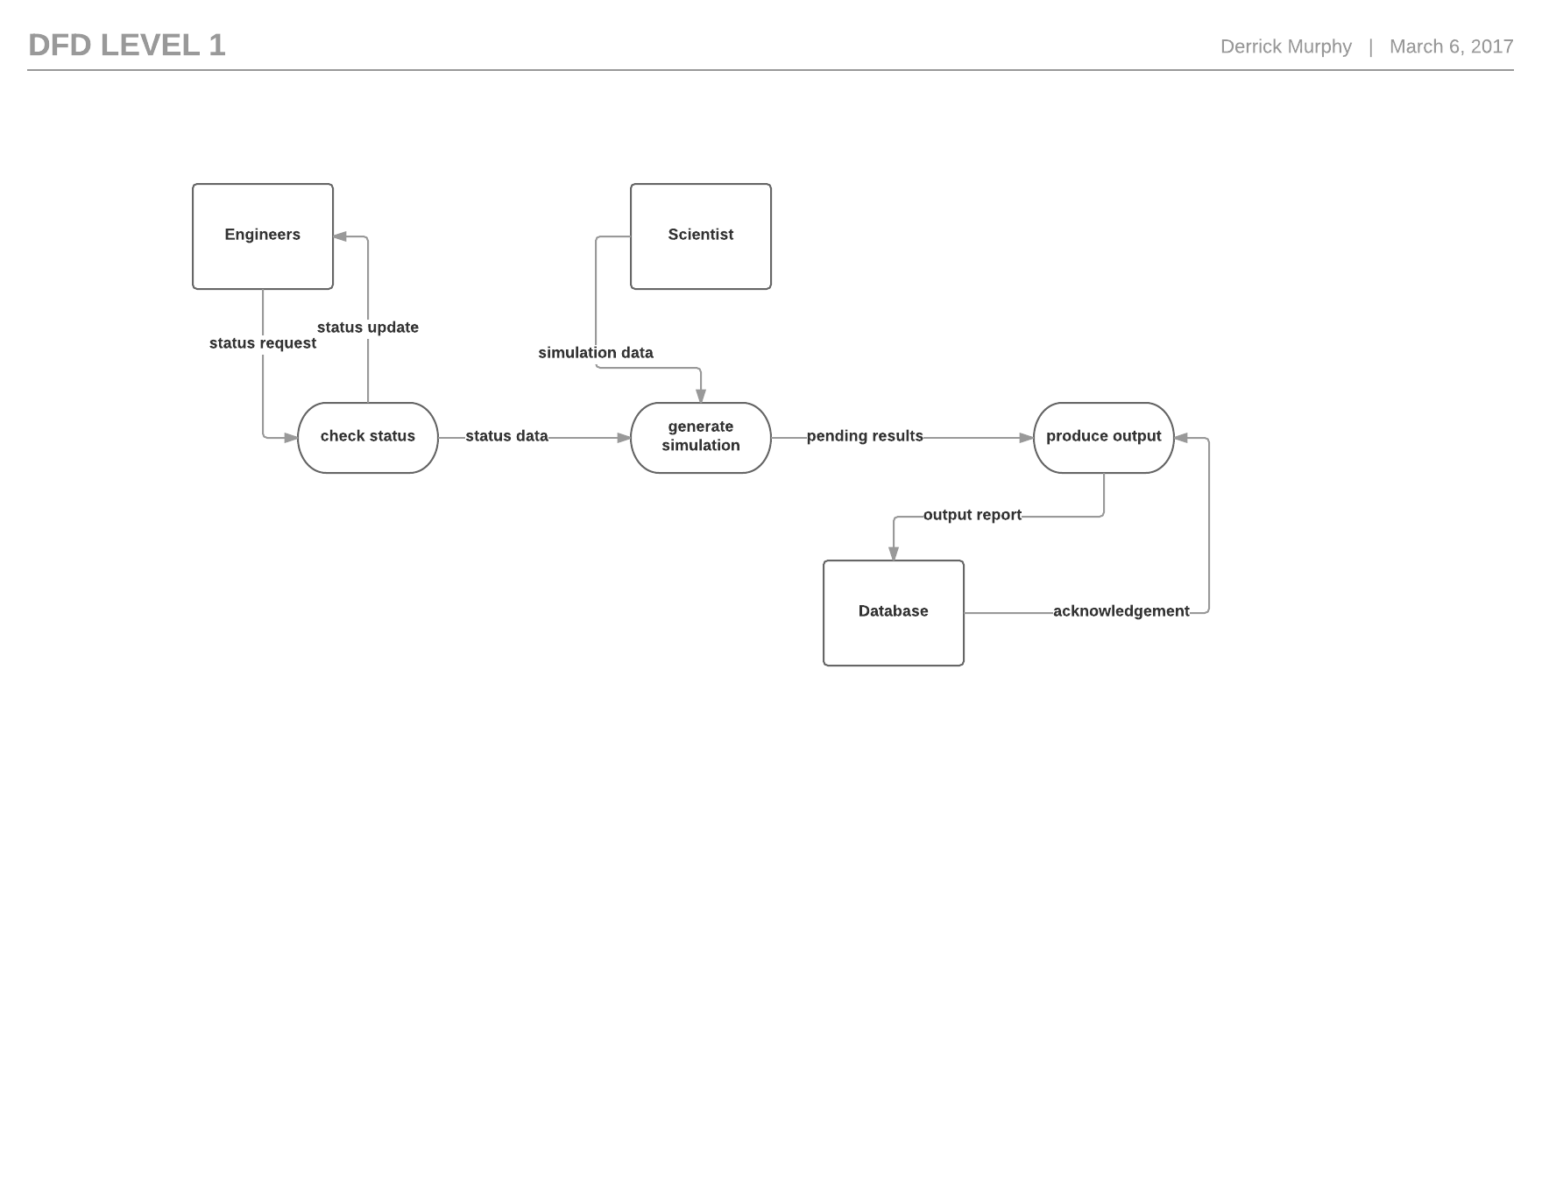

Software Design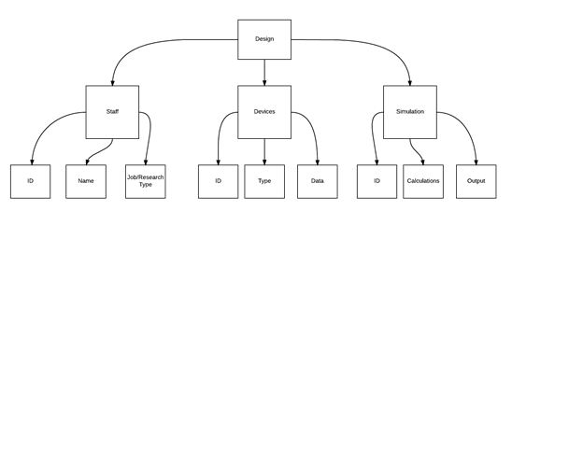

ERD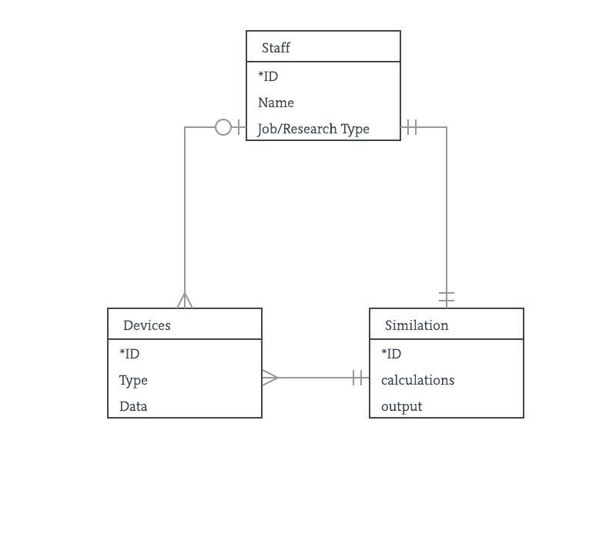Hardware/Network Design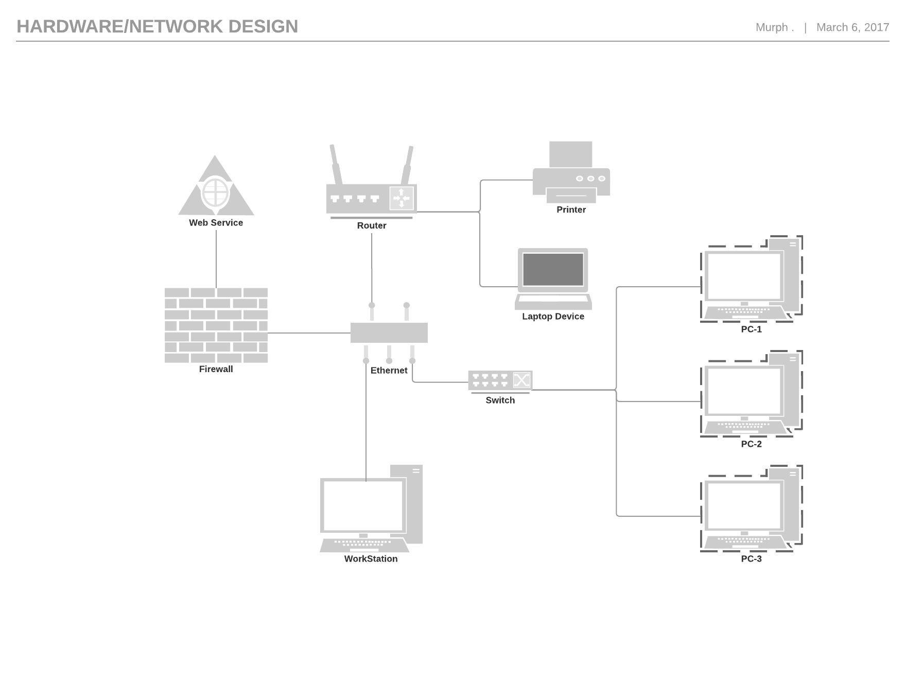

Use Case Diagram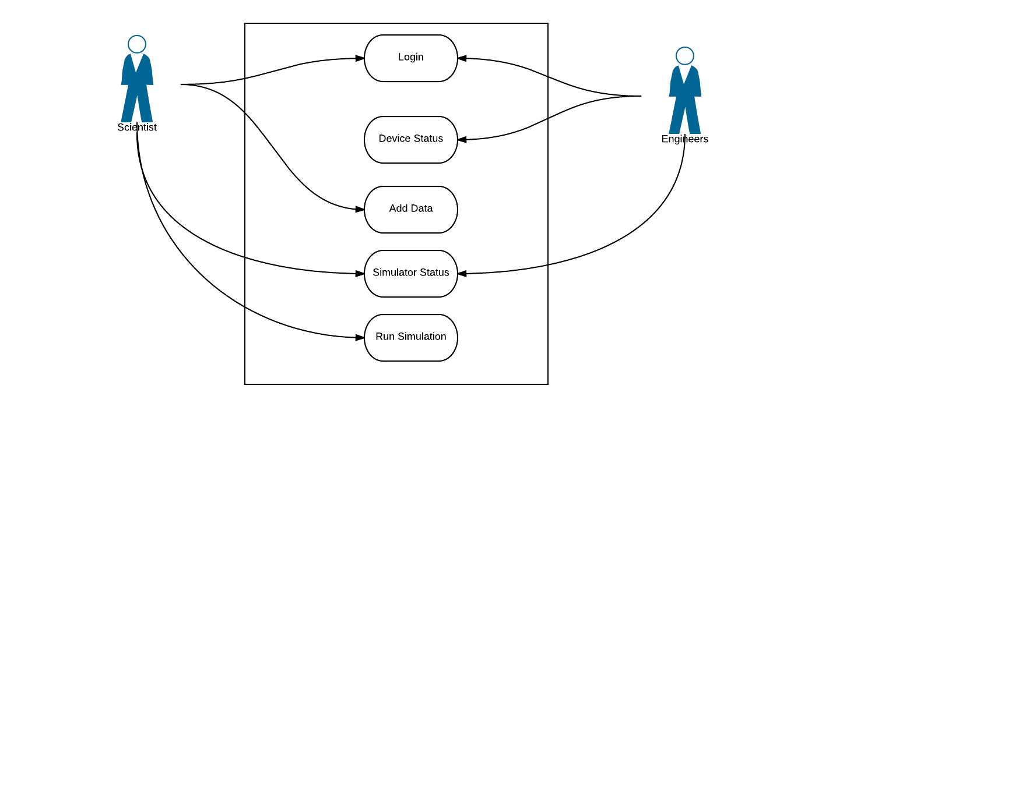

**Development**

